**TASK 3 : Aggregate functions, Having, Order By, GroupBy and Joins**

1. **Write a SQL query to List Events and Their Average Ticket Prices.**

SELECT event_name, AVG(ticket_price) AS avg_ticket_price

FROM Event

GROUP BY event_name;

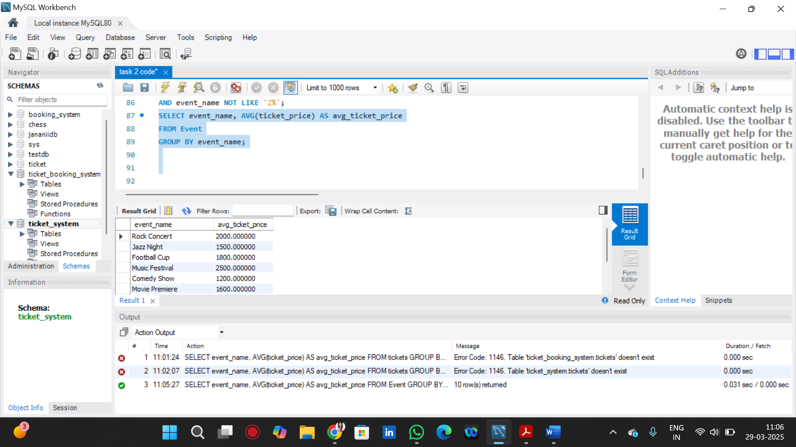

2. Write a SQL query to Calculate the Total Revenue Generated by Events.

SELECT e.event_name, SUM(b.num_tickets * e.ticket_price) AS total_revenue

FROM Booking b

JOIN Event e ON b.event_id = e.event_id

GROUP BY e.event_name;

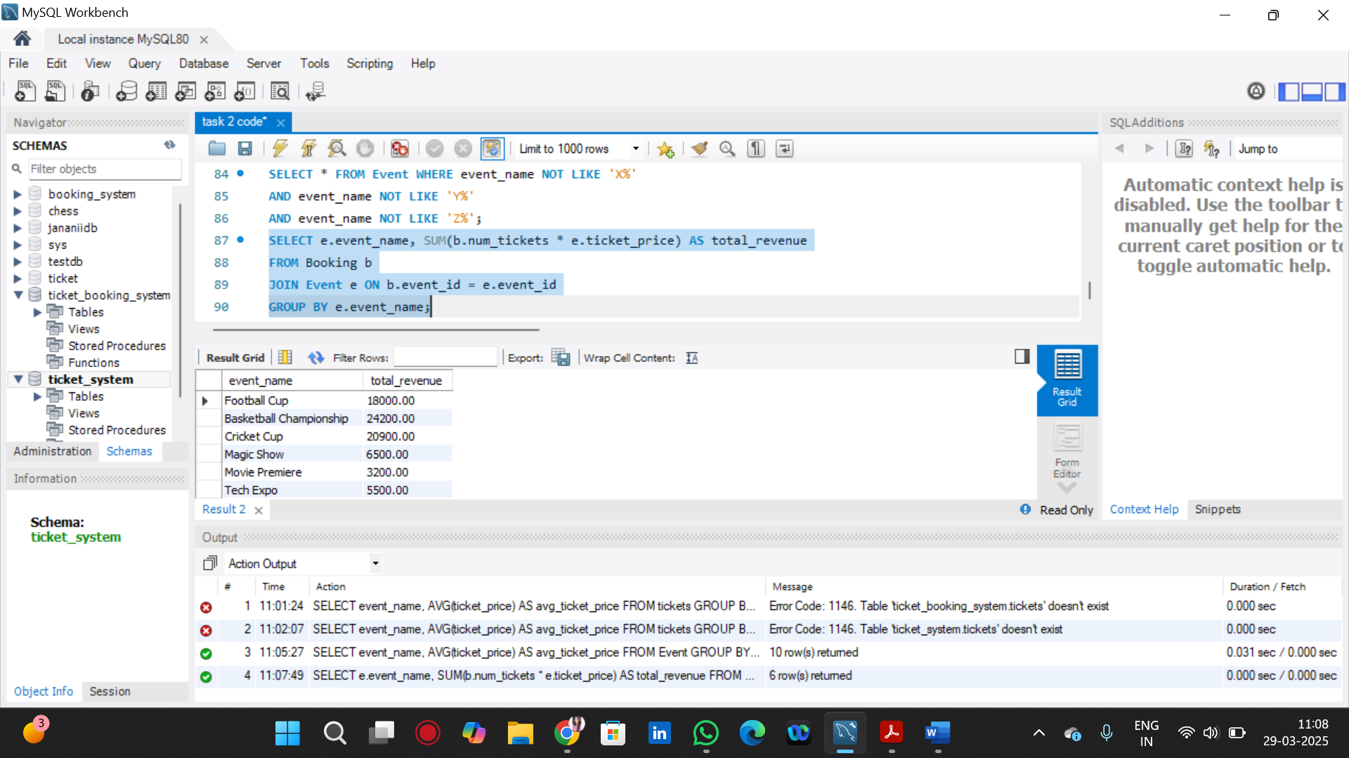

3. Write a SQL query to find the event with the highest ticket sales.

SELECT e.event_name, SUM(b.num_tickets) AS total_tickets_sold

FROM Booking b

JOIN Event e ON b.event_id = e.event_id

GROUP BY e.event_name

ORDER BY total_tickets_sold DESC

LIMIT 1;

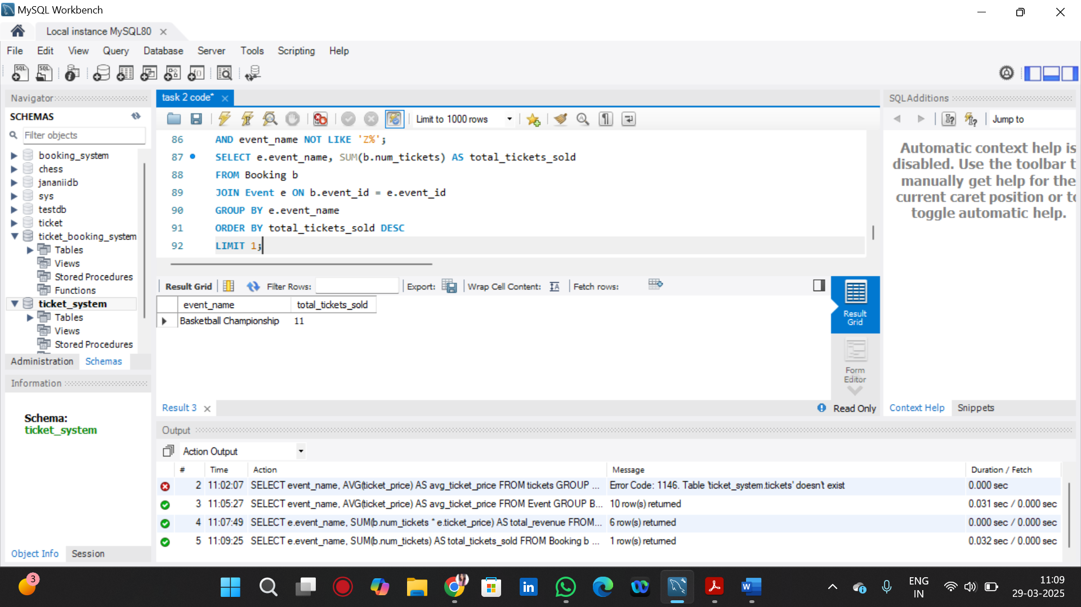

4. Write a SQL query to Calculate the Total Number of Tickets Sold for Each Event.

SELECT e.event_name, SUM(b.num_tickets) AS total_tickets_sold

FROM Booking b

JOIN Event e ON b.event_id = e.event_id

GROUP BY e.event_name;

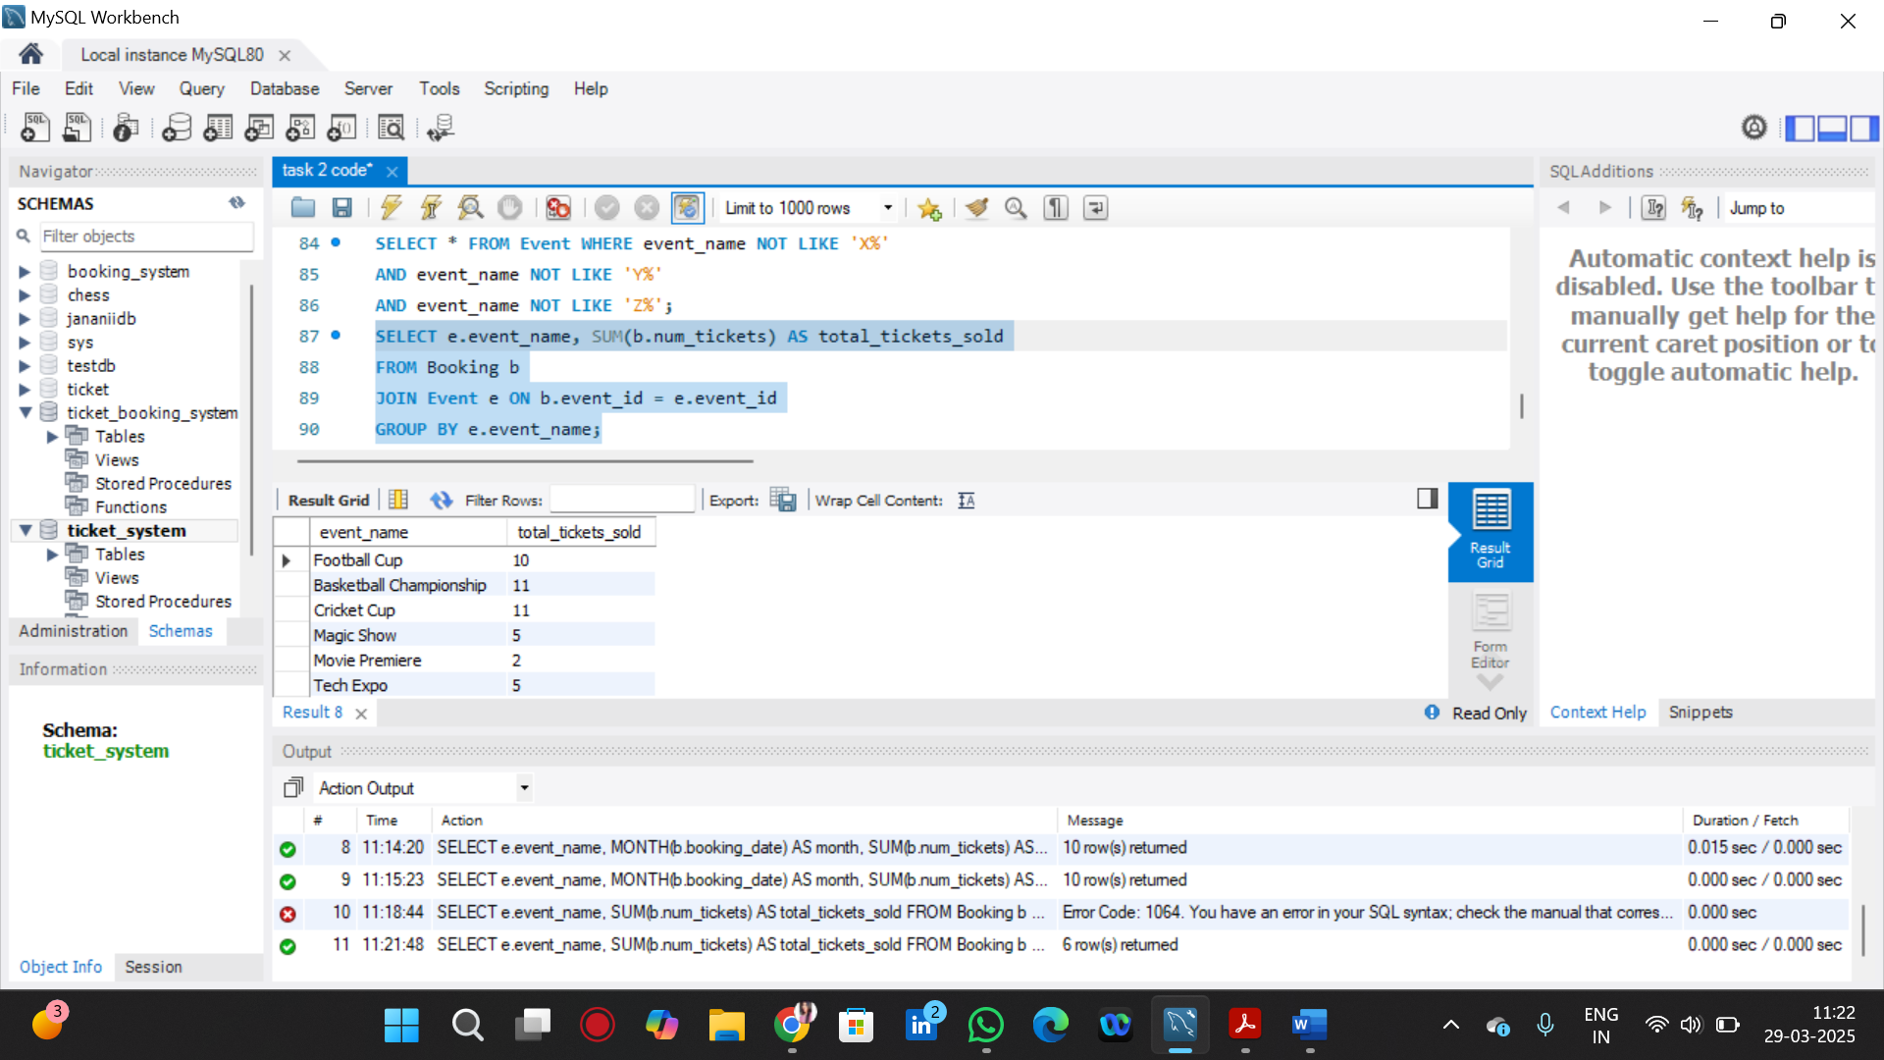

5. Write a SQL query to Find Events with No Ticket Sales.

SELECT e.event_name

FROM Event e

LEFT JOIN Booking b ON e.event_id = b.event_id

WHERE b.booking_id IS NULL;

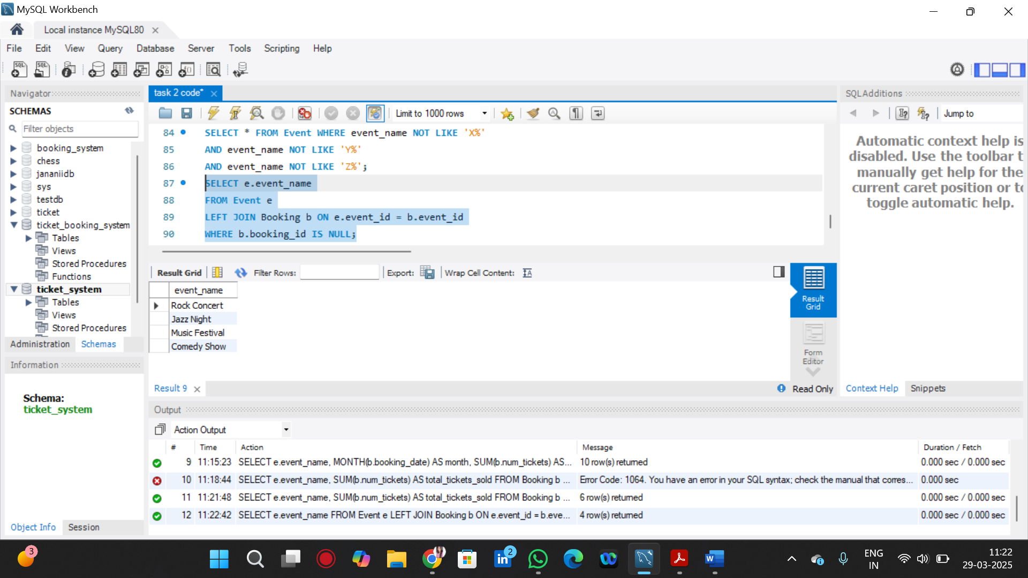

6. Write a SQL query to Find the User Who Has Booked the Most Tickets.

SELECT c.customer_name, SUM(b.num_tickets) AS total_tickets

FROM Booking b

JOIN Customer c ON b.customer_id = c.customer_id

GROUP BY c.customer_name

ORDER BY total_tickets DESC

LIMIT 1;

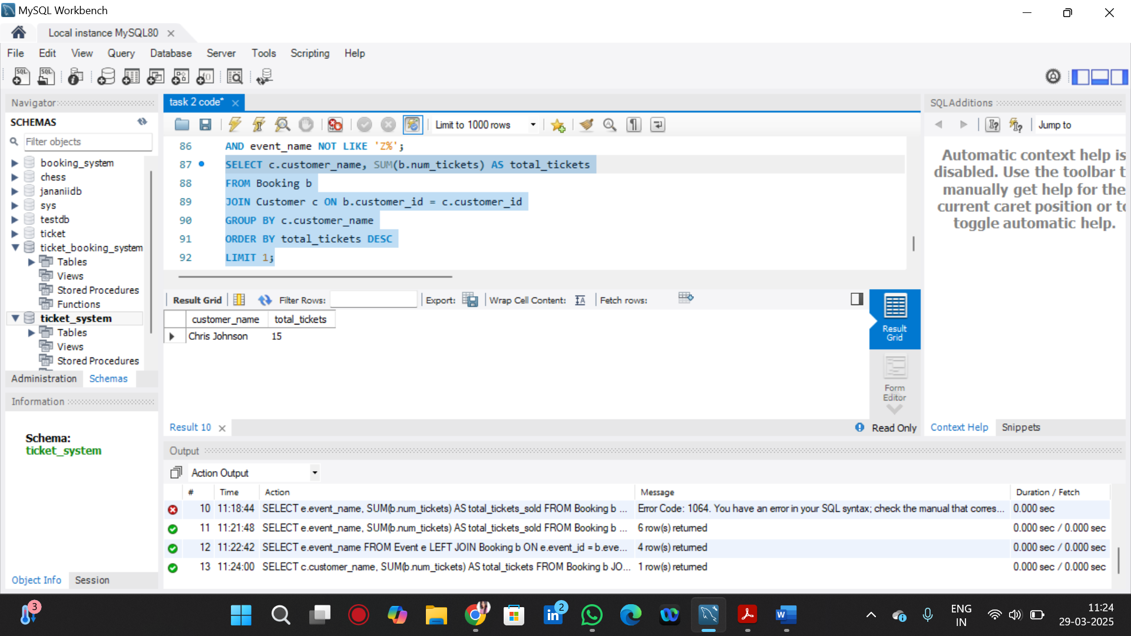

7. Write a SQL query to List Events and the total number of tickets sold for each month.

SELECT e.event_name, MONTH(b.booking_date) AS month, SUM(b.num_tickets) AS total_tickets_sold

FROM Booking b

JOIN Event e ON b.event_id = e.event_id

GROUP BY e.event_name, MONTH(b.booking_date)

ORDER BY month;

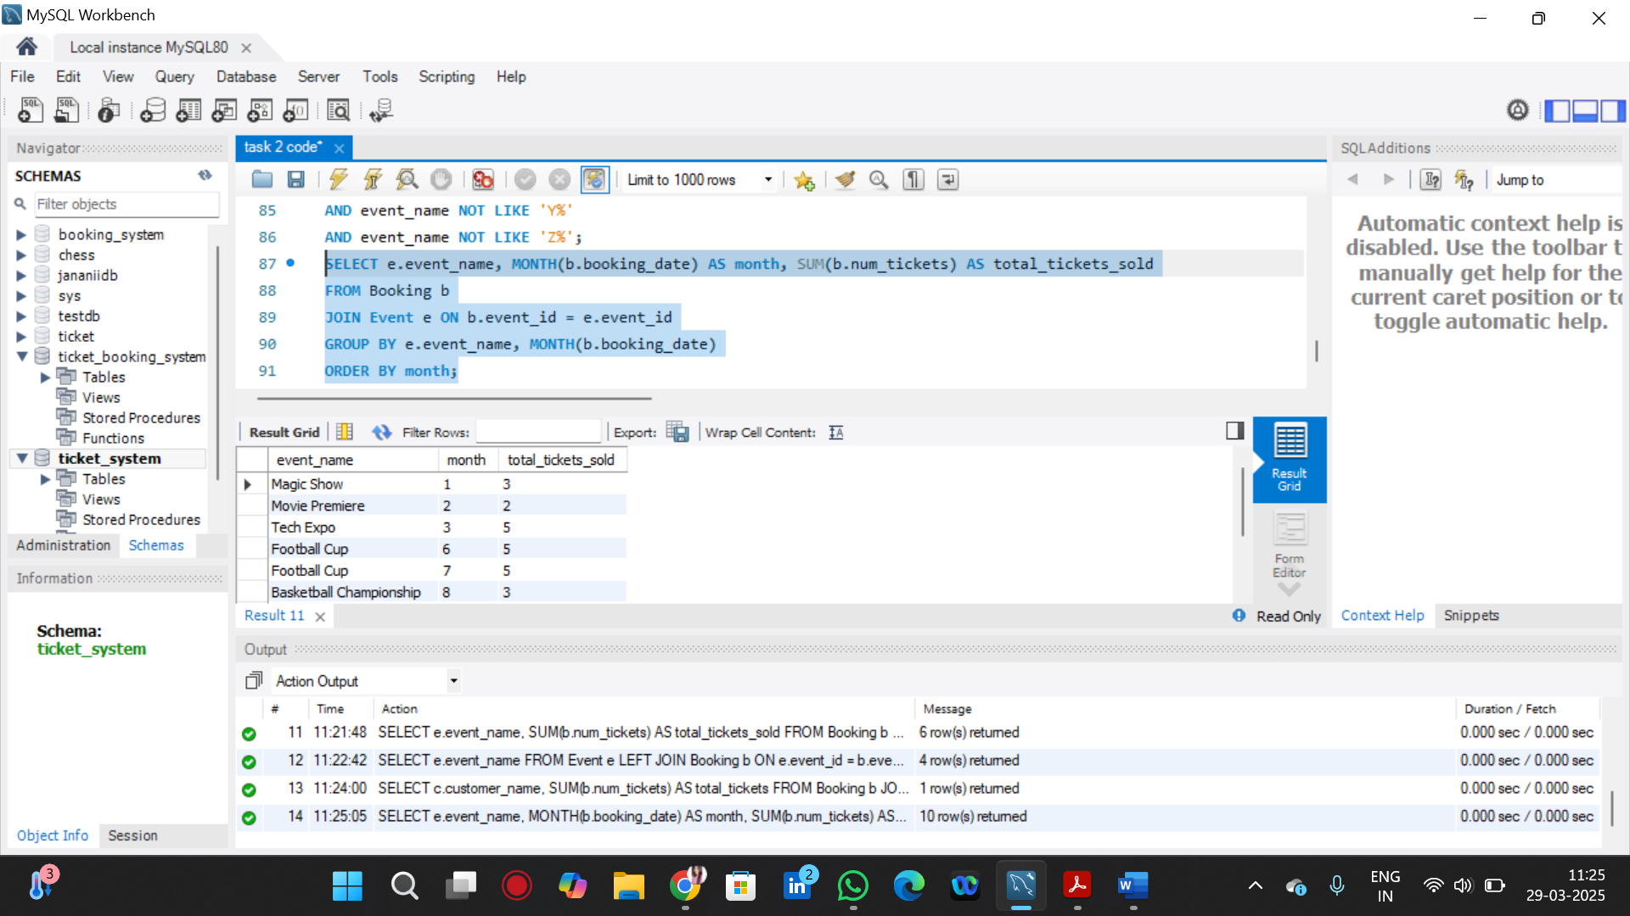

8. Write a SQL query to calculate the average Ticket Price for Events in Each Venue.

SELECT v.venue_name, AVG(e.ticket_price) AS avg_ticket_price

FROM Event e

JOIN Venue v ON e.venue_id = v.venue_id

GROUP BY v.venue_name;

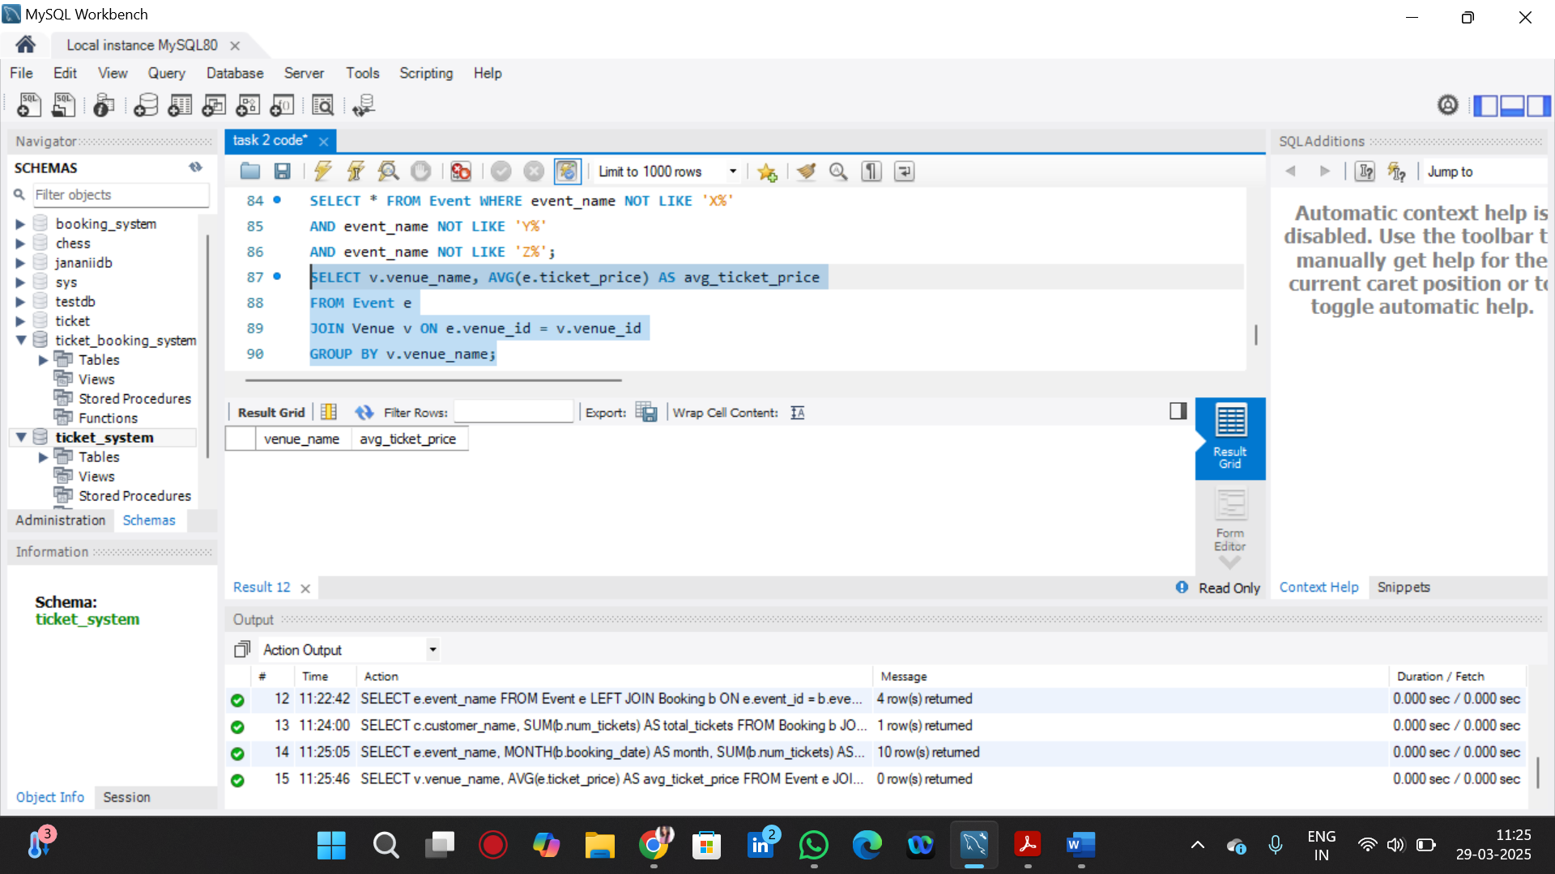

9. Write a SQL query to calculate the total Number of Tickets Sold for Each Event Type.

SELECT e.event_type, SUM(b.num_tickets) AS total_tickets_sold

FROM Event e

JOIN Booking b ON e.event_id = b.event_id

GROUP BY e.event_type;

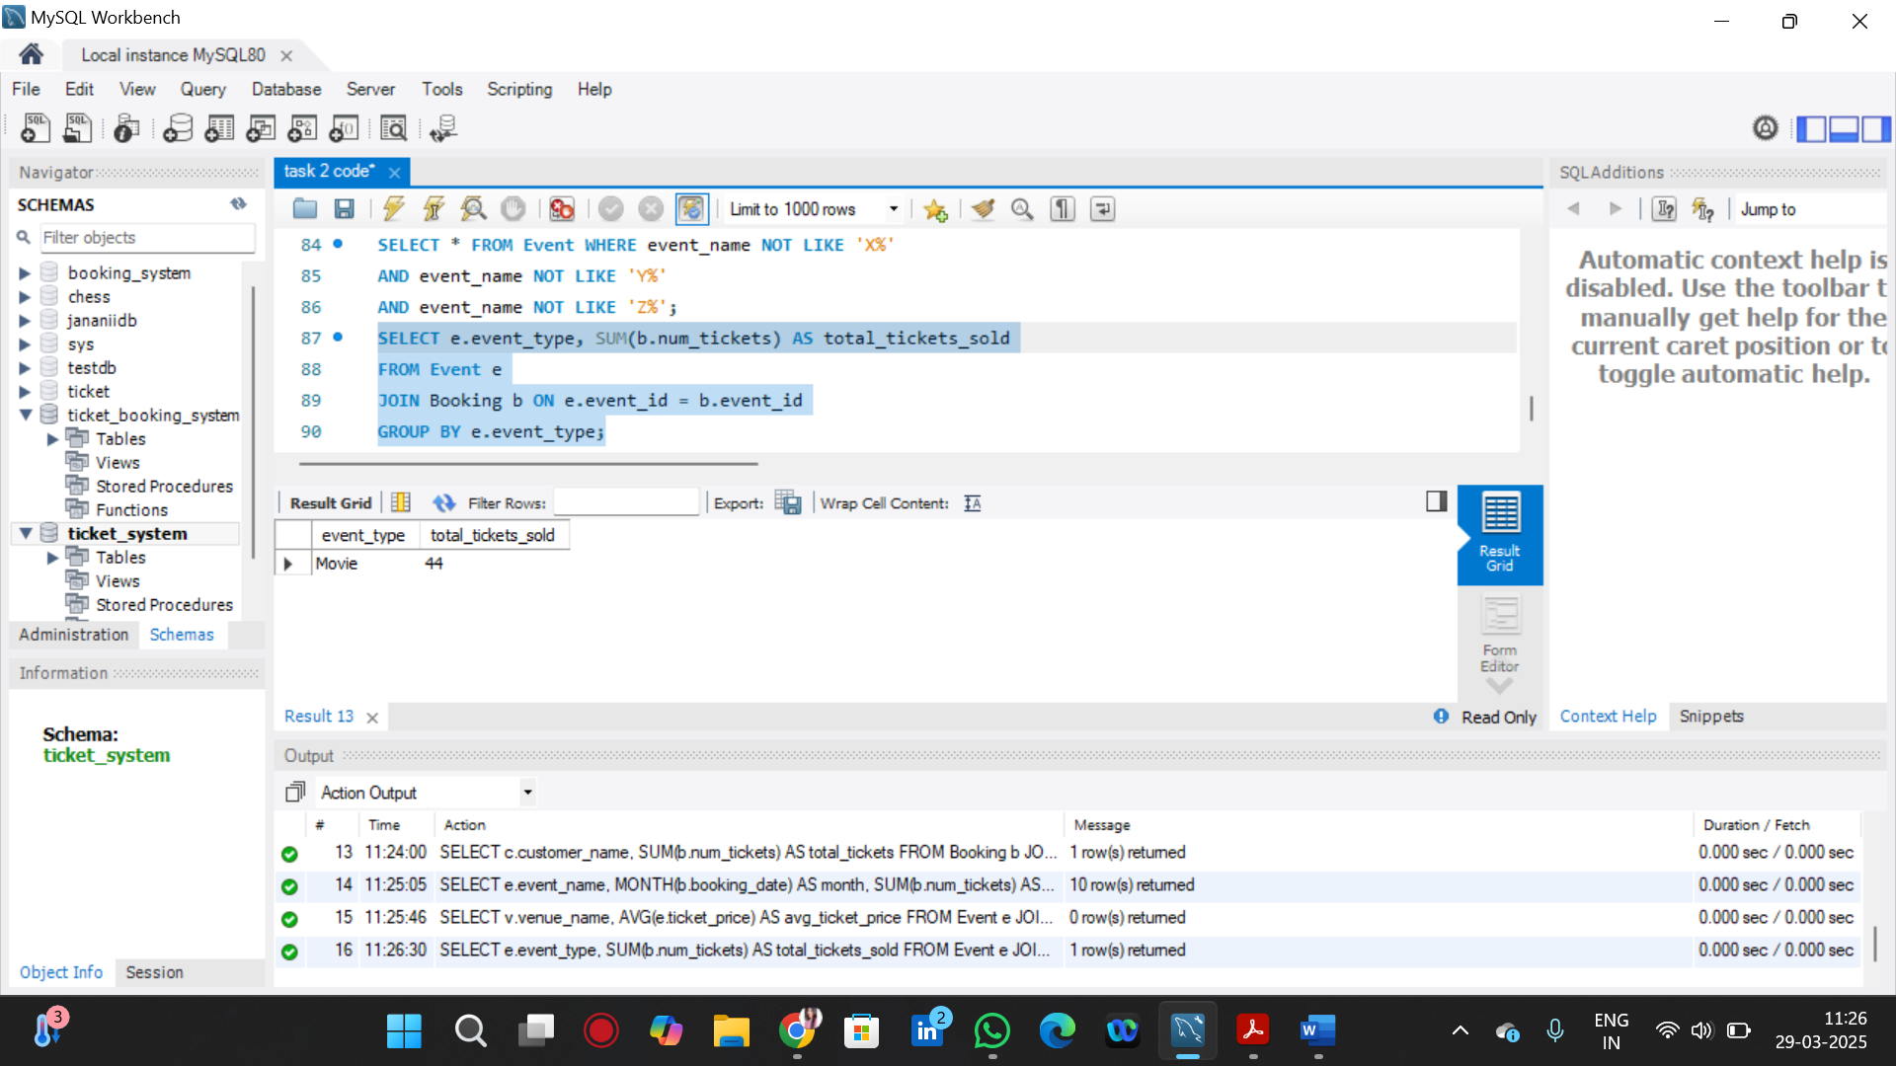

10. Write a SQL query to calculate the total Revenue Generated by Events in Each Year.

SELECT YEAR(b.booking_date) AS year, SUM(b.num_tickets * e.ticket_price) AS total_revenue

FROM Booking b

JOIN Event e ON b.event_id = e.event_id

GROUP BY YEAR(b.booking_date);

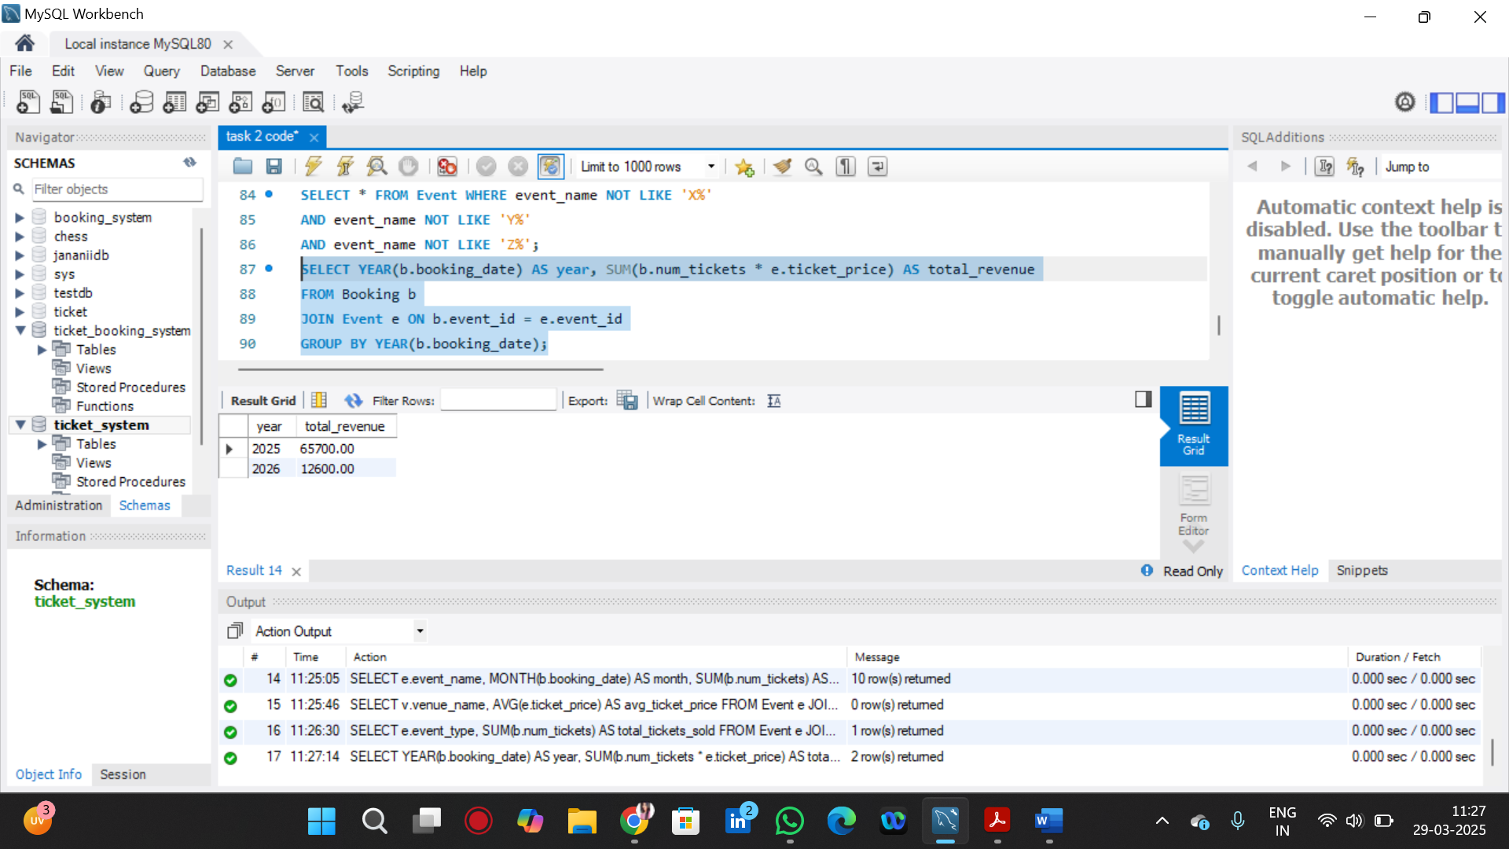

11. Write a SQL query to list users who have booked tickets for multiple events.

SELECT c.customer_name, COUNT(DISTINCT b.event_id) AS event_count

FROM Booking b

JOIN Customer c ON b.customer_id = c.customer_id

GROUP BY c.customer_name

HAVING event_count > 1;

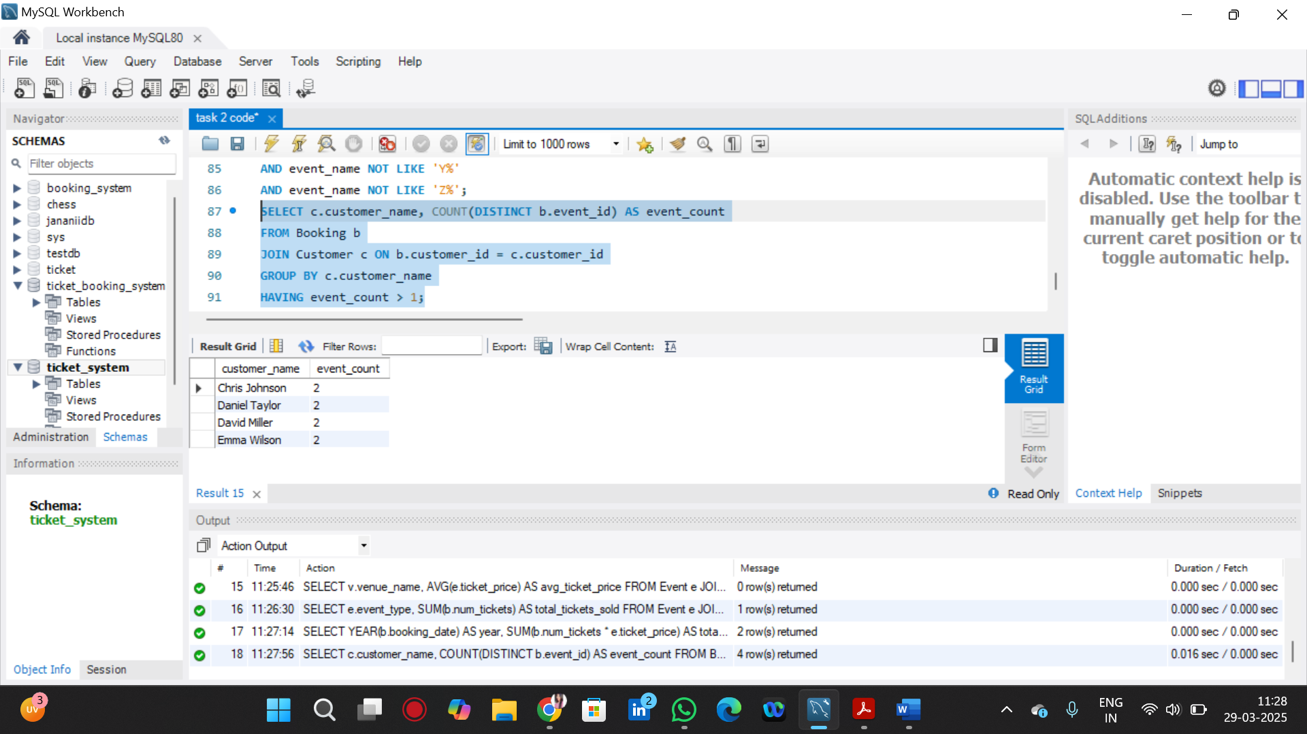

12.Write a SQL query to calculate the Total Revenue Generated by Events for Each User.

SELECT c.customer_name, SUM(b.num_tickets * e.ticket_price) AS total_revenue

FROM Booking b

JOIN Customer c ON b.customer_id = c.customer_id

JOIN Event e ON b.event_id = e.event_id

GROUP BY c.customer_name;

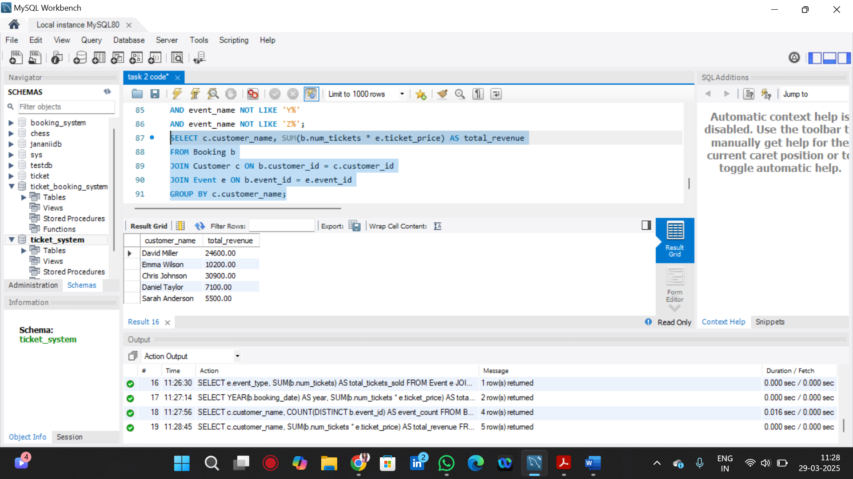

13. Write a SQL query to calculate the Average Ticket Price for Events in Each Category and Venue

SELECT e.event_type, v.venue_name, AVG(e.ticket_price) AS avg_ticket_price

FROM Event e

JOIN Venue v ON e.venue_id = v.venue_id

GROUP BY e.event_type, v.venue_name;

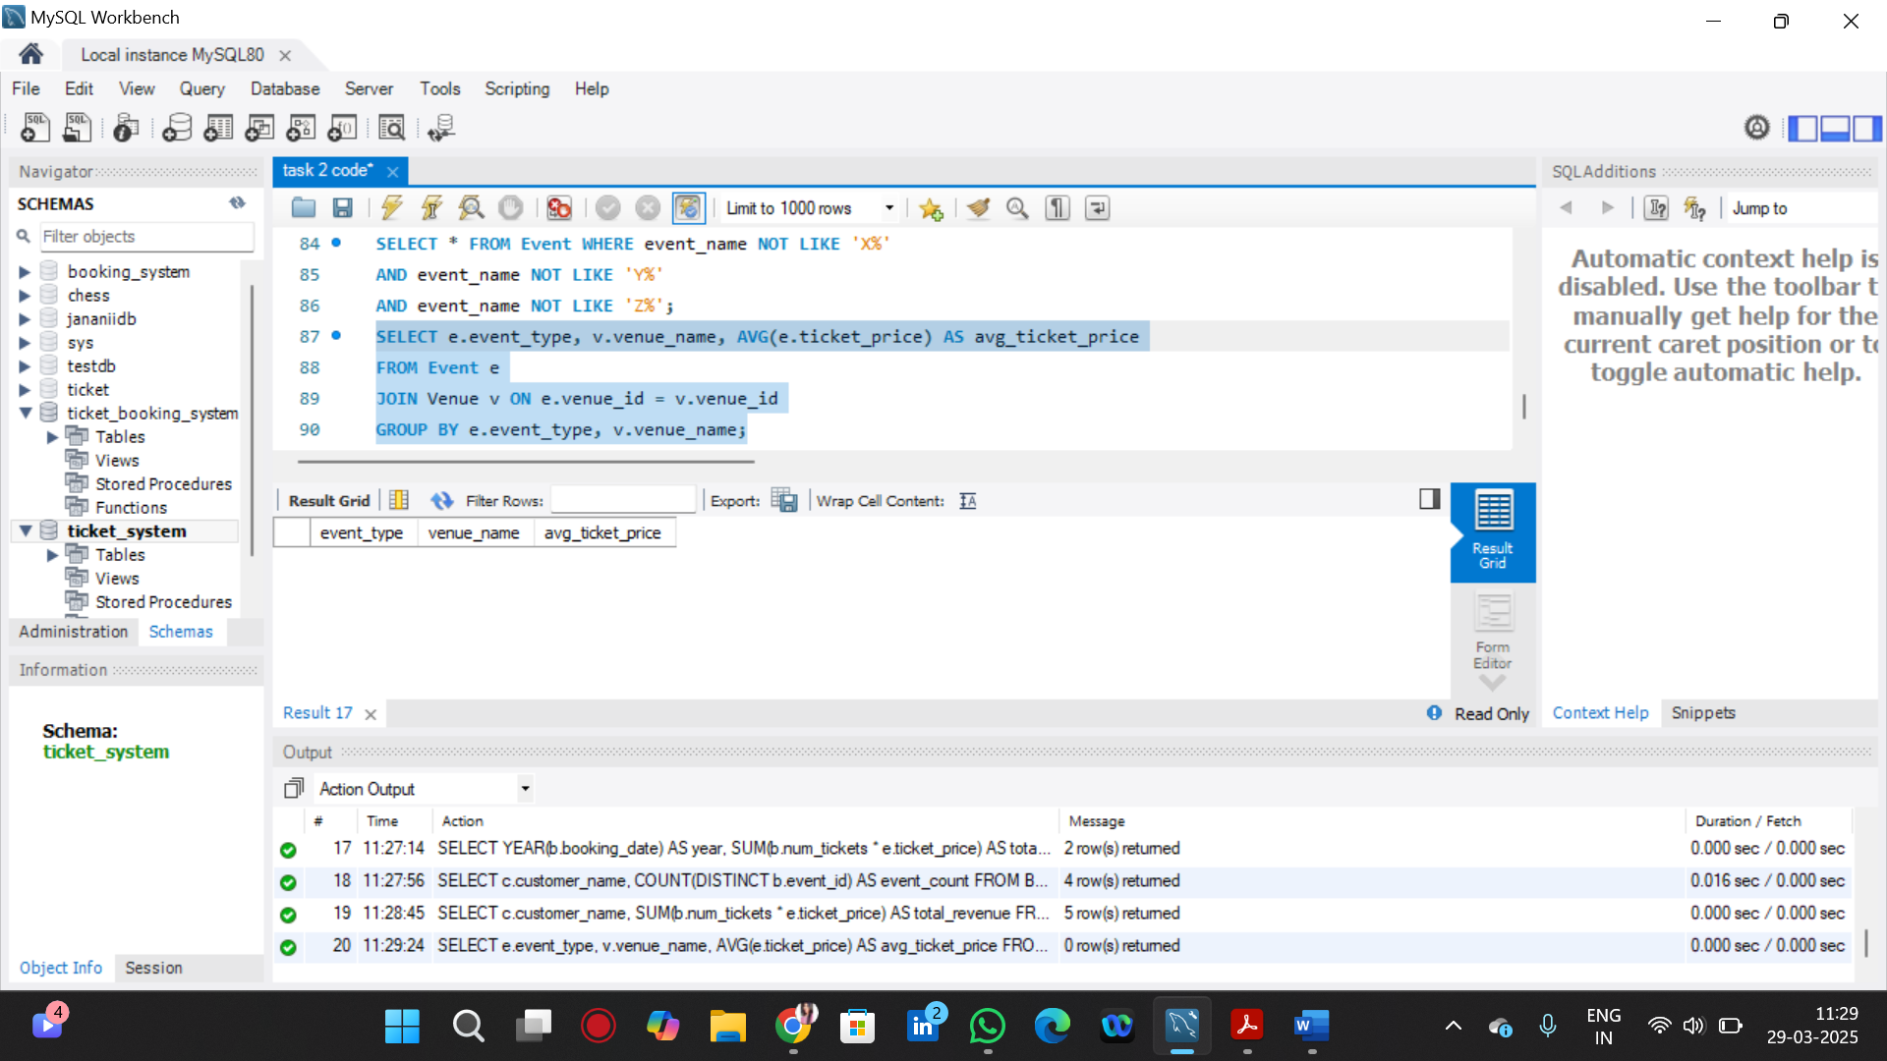

14. Write a SQL query to list Users and the Total Number of Tickets They've Purchased in the Last 30 Days.

SELECT c.customer_name, SUM(b.num_tickets) AS total_tickets_purchased

FROM Booking b

JOIN Customer c ON b.customer_id = c.customer_id

WHERE b.booking_date >= DATE_SUB(CURDATE(), INTERVAL 30 DAY)

GROUP BY c.customer_name;

